Reducing Seismic Risk by Seismic Retrofitting
in Latin America and the Caribbean

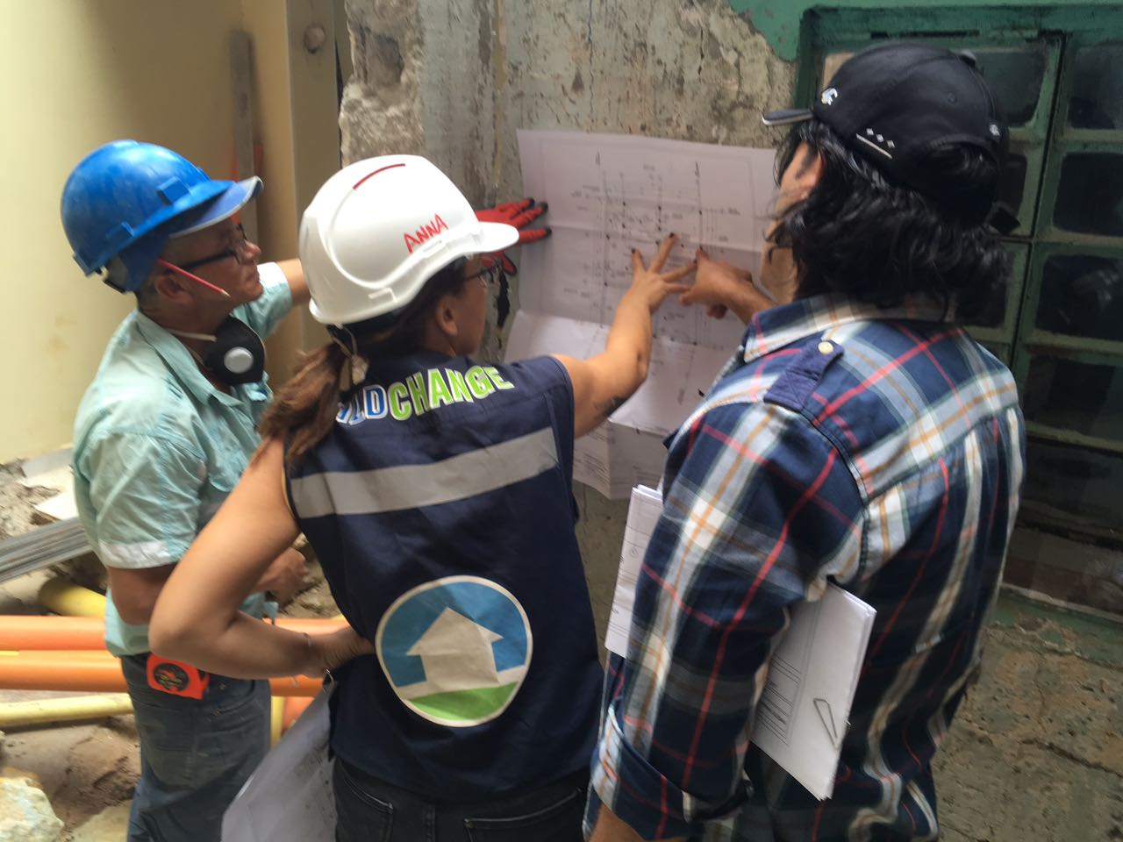
Build Change’s Lead Engineer for Latin America, Anna Pavan delivering on-the-job training of construction workers and Home Owners, on resilient structural rehabilitation of existing informal housing, and disaster resistant construction good practices.
Crédito de foto: Build Change, 2018

Por: Juan Caballero

BOGOTA, Colombia,9 de Marzo de 2018

Over 80% of Colombians live in cities. CENAC (Centro de Estudios de la Construcción y el Desarrollo Urbano y Regional), estimates up to 3/5 homes built in Colombia are informal.
To help address the seismic risk in Latin America and the Caribbean, Build Change launched a regional Latin American program in 2012, after a successful reconstruction program in Haiti since 2010.
In Haiti, Build Change pioneered an easy to use, cost effective method to evaluate and retrofit existing housing, and used the same approach to develop a retrofit manual for informal existing housing in Colombia. With the support of corporate partners, and municipal housing authorities, Build Change launched a pilot project to provide technical assistance to retrofit homes in Bogotá. In October 2016, Build Change obtained support from the Lloyds Charities Trust to begin a similar program in Medellin.
In Guatemala, we collaborated with AGIES, the Guatemalan Seismic Engineering Association, to develop a similar manual to evaluate and overcome existing housing seismic risk. In 2015, we completed 3 retrofits as part of a pilot project in association with PCI, and performed a feasibility study for the World Bank. The outcome: Retrofitting is feasible, cost effective, and a safe way to mitigate risk while re-densifying the city.
To date, Build Change’s work has led to 1,498 safer homes, 7,670 safer people, 11,357 people trained on retrofitting, We changed the practices of 22 organizations and our emphasis on tailoring best practices in engineering, construction, and design to local methods created 7,462 jobs.

La propuesta o proyecto según aplique “Reducing Seismic Risk by Seismic Retrofitting
in Latin America and the Caribbean” se presentará:

- JUEVES, 21 de junio del 2018 de las 17:20 a las 17:40 hrs.

En el espacio especialmente habilitado para el IGNITE stage en Cartagena de Indias, Colombia, en el marco de la VI Sesión de la Plataforma Regional para la Reducción del Riesgo de Desastres de las Américas (PR18).

Le invitamos a consultar http://eird.org/pr18/ignite-stage.html donde encontrará detalles de ésta y las otras presentaciones del Ignite Stage.

Enlaces relacionados:
Sitio web PR18
Sitio web UNISDR – Las Américas

